

***Dissertation on***

**“Reassembly of fragmented images using image stitching ”**

*Submitted in partial fulfilment of the requirements for the award of degree of*

**Bachelor of Technology**

**in**

**Computer Science & Engineering**

**UE20CS390B – Capstone Project Phase – 2**

***Submitted by:***

|  |  |
| --- | --- |
| **Gagan S**  **Hemanth Kalyan**  **Jasal Sadera**  **Shiraz Khan** | **PES1UG20CS145**  **PES1UG20CS163**  **PES1UG20CS175**  **PES1UG20CS255** |

*Under the guidance of*

**Prof. Sindhu R Pai**

Asst. Prof

Dept of CSE  
PES University

**August - December 2023**

**DEPARTMENT OF COMPUTER SCIENCE AND ENGINEERING**

FACULTY OF ENGINEERING

**PES UNIVERSITY**

(Established under Karnataka Act No. 16 of 2013)

100ft Ring Road, Bengaluru – 560 085, Karnataka, India



**PES UNIVERSITY**

(Established under Karnataka Act No. 16 of 2013)

100 Feet Ring Road, Bengaluru – 560 085, Karnataka, India

**CERTIFICATE**

*This is to certify that the dissertation entitled*

**‘Reassembly of fragmented images using image stitching’**

*is a bonafide work carried out by*

|  |  |
| --- | --- |
| **Gagan S**  **Hemanth Kalyan**  **Jasal Sadera**  **Shiraz Khan** | **PES1UG20CS145**  **PES1UG20CS163**  **PES1UG20CS175**  **PES1UG20CS255** |

in partial fulfilment for the completion of seventh semester Capstone Project Phase–2 (UE20CS390B) in the Program of Study - Bachelor of Technology in Computer Science and Engineering under rules and regulations of PES University, Bengaluru during the period August– December 2023. It is certified that all corrections / suggestions indicated for internal assessment have been incorporated in the report. The dissertation has been approved as it satisfies the 7th semester academic requirements in respect of project work.

|  |  |  |
| --- | --- | --- |
| Signature  Prof. Sindhu R Pai  Project Guide | Signature  Dr. Mamatha H R  Chairperson | Signature  Dr. B K Keshavan  Dean of Faculty |

**External Viva**

|  |  |
| --- | --- |
| **Name of the Examiners**  **1.** __________________________  **2. __________________________** | **Signature with Date**  __________________________  **__________________________** |

**DECLARATION**

We hereby declare that the Capstone Project Phase - 2 entitled **“Reassembly of fragmented images using image stitching”** has been carried out by us under the guidance of Prof. Sindhu R Pai, Asst. Prof, PES University and submitted in partial fulfilment of the completion of sixth semester of **Bachelor of Technology** in **Computer Science and Engineering** of **PES University, Bengaluru** during the academic semester August - December 2023. The matter embodied in this report has not been submitted to any other university or institution for the award of any degree.

|  |  |  |
| --- | --- | --- |
| **PES1UG20CS145** | **Gagan S** |  |
| **PES1UG20CS163** | **Hemanth Kalyan** |  |
| **PES1UG20CS175** | **Jasal Sadera** |  |
| **PES1UG20CS255** | **Shiraz Khan** |  |

**ACKNOWLEDGEMENT**

We would like to express our gratitude to Prof. Sindhu R Pai, Department of Computer Science and Engineering, PES University, for her continuous guidance, assistance, and encouragement throughout the development of this UE19CS390A - Capstone Project Phase – 2.

We are grateful to the project coordinator, Dr. Priyanka H., all the panel members & the supporting staff for organizing, managing, and helping the entire process.

We take this opportunity to thank Dr. Mamatha H R, Chairperson, Department of Computer Science and Engineering, PES University, for all the knowledge and support we have received from her.

We are grateful to Dr. M. R. Doreswamy, Chancellor, PES University, Prof. Jawahar Doreswamy, Pro Chancellor – PES University, Dr. Suryaprasad J, Vice-Chancellor, Dr. B.K. Keshavan, Dean of Faculty, PES University for providing us various opportunities and enlightenment during every step of the way.

Finally, this project could not have been completed without the continual support and encouragement we have received from our family and friends.

**ABSTRACT**

The goal of this project is to create a forensic tool – an Image Stitching System that can repair

shredded papers or old, damaged images. Advanced picture stitching techniques and inpainting algorithms are used to piece together fractured photos and to fill in any gaps respectively.

The main objective is to precisely rebuild the original image and recover its content for a variety of

purposes, including forensics and personal documentation. The tool allows users to input pieces of an image which are then processed by the model to extract useful features of each piece. It then uses a thoroughly trained deep-learning algorithm to reassemble the pieces to give a predicted output of the image. If there are any missing pieces, it is passed through another model containing inpainting algorithms to fill the gaps by generatively filling it. The result is one final image. The web app is designed to be user friendly and allows the user to download the image generated.

**TABLE OF CONTENTS**

|  |  |  |  |
| --- | --- | --- | --- |
| **Chapter No.** | **Title** |  | Page No. |
| **1.** | **INTRODUCTION** |  | 1 |
| **2.** | **PROBLEM STATEMENT** |  | 2 |
| **3.** | **LITERATURE REVIEW** |  | 3 |
|  | 3.1 Unsupervised Learning of Visual Representations by Solving Jigsaw Puzzles |  | 3 |
|  | 3.2 EdgeConnect: Structure Guided Image Inpainting using Edge Prediction |  | 4 |
|  | 3.3 A Genetic Algorithm-Based Solver for Very Large Jigsaw Puzzles |  | 5 |
|  | 3.4 MAT: Mask-Aware Transformer for Large Hole Image Inpainting |  | 6 |
|  | 3.5 An Automated System for Image Reconstruction from Distorted Image Fragments |  | 7 |
| **4.** | **SYSTEM REQUIREMENTS SPECIFICATION** |  | 9 |
| **5.** | **SYSTEM DESIGN** |  | 18 |
| **6.** | **PROPOSED METHODOLOGY** |  | 24 |
| **7.** | **IMPLEMENTATION AND PSEUDOCODE** |  | 26 |
| **8.** | **RESULTS AND DISCUSSION** |  | 30 |
| **9.** | **CONCLUSION AND FUTURE WORK** |  | 31 |
| **REFERENCE/ BIBLIOGRAPHY** | |  | 32 |
| [**APPENDIX A DEFINITIONS, ACRONYMS AND ABBREVIATIONS**](https://docs.google.com/document/d/1sxLzRaxGh0fTgzlXiH-5RgoxpmOZgtX9RD5OH3Dfigw/edit#heading%3Dh.qzpp4n2gssp1) | |  | 33 |
|  |  |  |  |

**LIST OF FIGURES**

|  |  |  |
| --- | --- | --- |
| **Figure No.** | **Title** | **Page No.** |
|  |  |  |
| Figure 1 | Step-by-step process of creating and solving a jigsaw puzzle | 3 |
| Figure 2 | Various outputs generated by the diffusion model | 5 |
| Figure 3 | Genetic Algorithm solving a 10,000-piece puzzle of a statue. | 7 |
| Figure 4 | Local Puzzles solved, but Global position being shifted | 7 |
| Figure 5 | Inpainting results after mask application. | 8 |
| Figure 6 | Horizontal combinations are concatenated vertically to form the final reconstructed image. | 9 |
| Figure 7 | High Level Design View | 23 |
| Figure 8 | Master-Class diagram | 24 |
| Figure 9 | System Outline | 26 |
| Figure 10 | Input to the Jigsaw-Solver | 27 |
| Figure 11 | Outputs generated by the Jigsaw-Solver | 28 |
| Figure 12 | Inpainting results on the given inputs | 28-29 |
| Figure 13 | Jigsaw Model Block Diagram | 32 |
| Figure 14 | Solving irregular pieced cheques | 35-36 |
| Figure 15 | Results and Statistics for human faces | 37 |
| Figure 16 | Results and Statistics for Paintings | 38-39 |
| Figure 17 | GAN vs Diffusion model inpainting | 40-41 |
| Figure 18 | GAN model inpainting | 41 |

**LIST OF TABLES**

|  |  |  |
| --- | --- | --- |
| **Figure No.** | **Title** | **Page No.** |
| Table 1 | External Interface Requirements | 15 |
| Table 2 | Performance Requirements | 17 |

**CHAPTER 1**

**INTRODUCTION**

In the present era dominated by digital data, certain domains like forensics, surveillance, and banking, continue to rely on physical formats like paper and images. Despite the important roles these tangible records play, they are susceptible to various forms of destruction—forensic evidence may be compromised, aged photos can be torn or deteriorated, and vital documents, including cheques, may be accidentally shredded. In such scenarios, our model proves invaluable by significantly minimizing the human effort traditionally expended on the laborious task of manually piecing together fragmented information.

**CHAPTER 2**

**PROBLEM STATEMENT**

This project focuses on creating an advanced system for reconstructing images from fragmented pieces, similar to solving a jigsaw puzzle but with the added challenge of not knowing the final image beforehand. The aim is to provide a faster and more efficient alternative to manual reassembly.

Our system is designed to handle various types of images, including physical photos like polaroids, as well as challenging scenarios such as shredded, partially burnt, and disfigured documents. Unlike traditional jigsaw puzzle solvers, our system excels in situations where the final image is uncertain.

Key to our approach is not only accurately stitching together image fragments but also intelligently addressing missing pieces using an inpainting module. Success will be measured by the accuracy of the stitched image and the user-likability of inpainting, ensuring a visually pleasing and user-acceptable outcome.

In summary, our project aims to deliver an innovative solution that surpasses traditional methods, providing a faster and more effective way to reconstruct images from fragmented pieces, regardless of the initial damage or distortion.

**CHAPTER 3**

**LITERATURE REVIEW**

For our literature review, we went through various papers centered on the reconstruction of fragmented images and inpainting methodologies. After a few deeper studies into these papers, we have distilled our focus to five specific papers that, in our evaluation, stand out for offering richer insights and information than their counterparts in the field for out project.

**3.1 Unsupervised Learning of Visual Representations by Solving Jigsaw Puzzles**

Mehdi Noroozi and Paolo Favaro

**Summary:**

The paper introduces a unique unsupervised learning approach that involves solving a jigsaw puzzle to develop features suitable for object detection and classification. Initially, the model learns essential image features by solving jigsaw puzzles created from natural images. Subsequently, these acquired capabilities are refined using a smaller set of labeled examples. The paper presents a specialized neural network known as the context-free network (CFN) to facilitate the application of these skills to other tasks. The CFN dissects images into pieces and determines their arrangement. The study demonstrates that the computer, equipped with these acquired skills, outperforms other methods when subjected to various tasks.

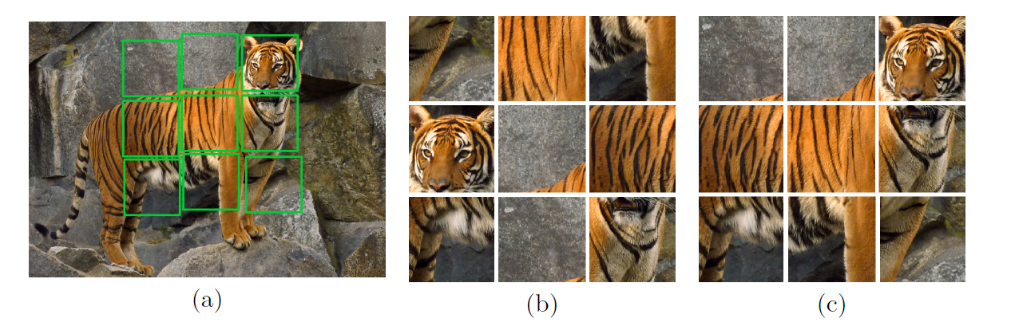

*Figure 1: Step-by-step process of creating and solving a jigsaw puzzle*

**Takeaways :**

The spatial relationships inherent in solving jigsaw puzzles prove to be a valuable source of information for training neural networks to extract meaningful features from images.

The efficiency of a CFN in capturing semantic content with fewer parameters than traditional architectures is notable.

Even though they’ve used pieces of a jigsaw puzzle for classifying features of an image, the pieces involved aren’t subject to noise or any occlusion which is a key point for the need of inpainting in our project. As of 2023, their current model is only applicable on animal classification

**3.2 Palette: Image-to-Image Diffusion Models**

Chitwan Saharia, William Chan, Huiwen Chang, Chris A. Lee, Jonathan Ho, Tim Salimans, David Fleet and Mohammad Norouzi

**Summary:**

The paper utilizes a conditional diffusion model which is used in the study to perform inpainting tasks on realistic pictures. The purpose of training this model is to reverse a stochastic diffusion process, which adds noise to a picture piece by piece until it becomes pure noise. The model acts on damaged photos with particular regions replaced by a constant value, resulting in a denoised and inpainted image. It was trained using the Places2 and CelebA-HQ datasets. The model is able to generate several iterations of a picture with gaps because it is flexible in handling different sizes and forms of missing patches. It was trained on a large dataset of natural photos without human annotations.

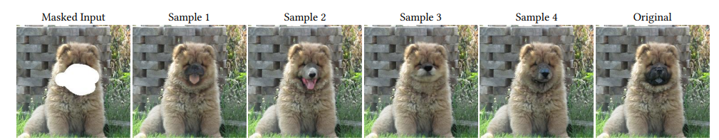

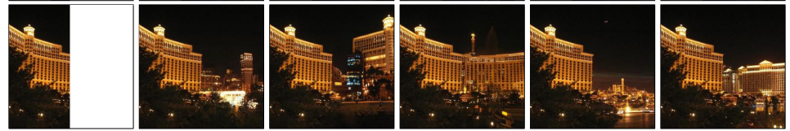

*Figure 2: Various outputs generated by the diffusion model*

**Takeaways :**

The analysis shows that the conditional diffusion model outperforms current techniques, such as those based on GANs and regression, in producing realistic and varied inpainting results over a range of measures.

The paper’s technique was able to create sections of a face using the paper's breakthrough crossover approach, which blends pieces from other photographs to produce unique inpainting outcomes.

This model was of great use to our project in-terms of the output generated for our dataset but lacks in the recognition of the area to be inpainted, sometimes leading to abhorrent images of human faces which might induce negative regard of the model.

**3.3 A Genetic Algorithm-Based Solver for Very Large Jigsaw Puzzles**

Dror Sholomon Omid David and Nathan S. Netanyahu

**Summary:**

The paper presents the first automated solver for very large jigsaw puzzles based on genetic algorithms (GAs). The solver uses a novel crossover technique that detects, extracts, and combines correctly assembled puzzle segments from two parent solutions to produce an improved child solution. It improves on an older greedy algorithm that iteratively merges pairs of pieces with the highest compatibility score.

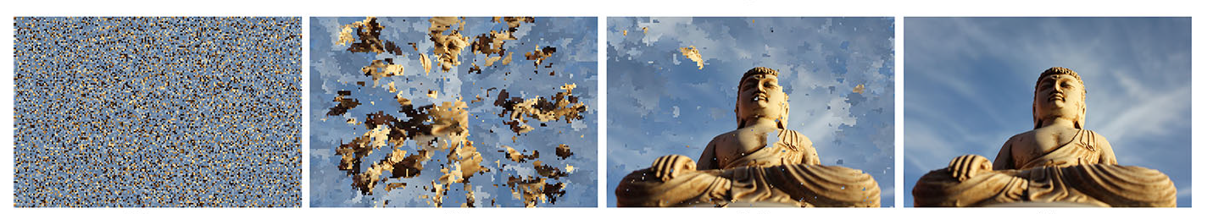

*Figure 3: Genetic Algorithm solving a 10,000-piece puzzle of a statue.*

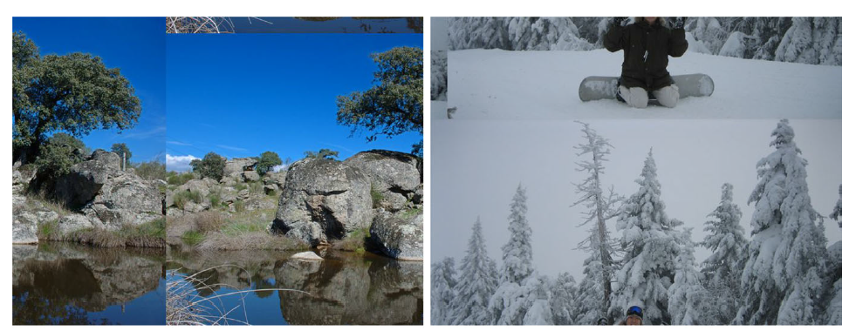

*Figure 4: Local Puzzles solved, but Global position being shifted*

**Takeaways :**

Genetic Algorithms can explore a diverse and large solution space by using crossover and mutation operators that combine and modify existing solutions.

Although the model does solve local pieces, it still needs the help of another algorithm to place the pieces i.e., it can solve local puzzles, but global positioning still has a lower accuracy. This is evident from Figure 4. This is because it doesn’t have any context about the original image.

**3.4 MAT: Mask-Aware Transformer for Large Hole Image Inpainting**

Wenbo Li,Zhe Lin,Kun Zhou,Lu Qi,Yi Wang, Jiaya Jia

**Summary:**

This paper uses a special type of neural network called transformer, which can learn the global and local relationships by making use of an encoder and a decoder. The encoder takes the original image and the mask (showing where the hole is) as inputs and converts them into small pieces called tokens. Each token represents some information about a part of the image, such as its color, shape, or texture. The decoder takes the tokens from the encoder and tries to generate new tokens for the missing parts of the image.

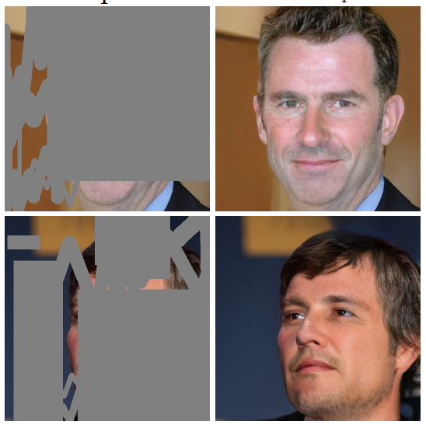

*Figure 5: Inpainting results after mask application.*

**Takeaways:**

The mask-aware transformer (MAT) is a novel model that combines the advantages of transformers and convolutions to achieve high-quality and diverse inpainting results for large holes in images.

While the encoder decoder structure of a transformer works, it needs a mask to be applied over the input image to know where the inpainting is to be done which becomes a disadvantage for a user using our project to inpaint any occluded image.

**3.5 An Automated System for Image Reconstruction from Distorted Image Fragments**

Maitri Tewari, Susovan Jana, Ranjan Parekh

**Summary:**

This paper talks on how image reconstruction is beneficial to save human effort and time. It mentions how the actual image can be reconstructed via this automated system which consists of mainly 4 steps being Noise removal, Orientation Correction, Fragment Selection for each position and stitching the fragments.

In this paper there are different techniques used for fulfilling the major requirements for image reconstruction those being SURF (speed up robust feature), Hessian-Laplacian detector, MATLAB, cumulative distribution function for histogram, median filter.

The paper provides the success percentage along with time taken to stitch whenever there is increase in the image fragments and how successful the product is working. Firstly, test results were generated for image fragmented 6 then 16 later 24. It was observed that there was slight increase in time as no. of fragments increased.

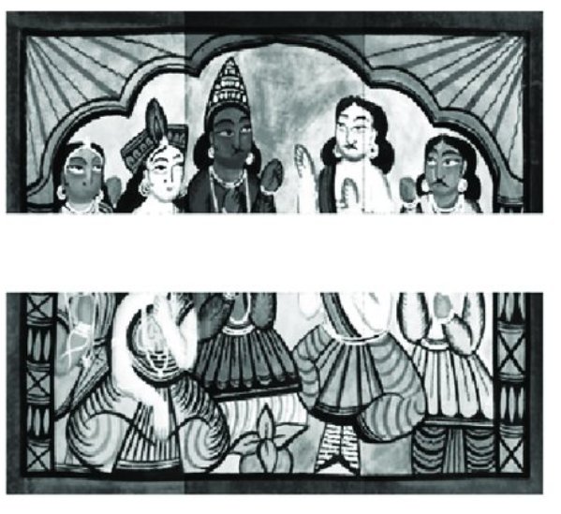 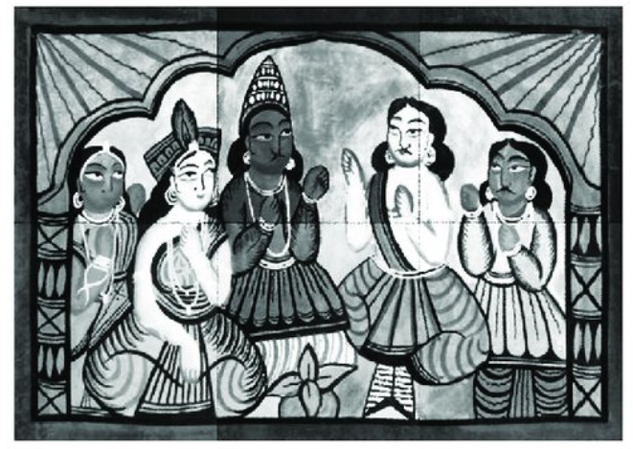

*Figure 6: Horizontal combinations are concatenated vertically to form the final reconstructed image.*

**Takeaways:**

Median filter used for noise filtering which is easy to compute and effective in noise removal.

SURF is a better alternative to compute with rather than SIFT for orientation correction.

Fragment selection taking place with 1 key fragment and others compared to it where the most accurate fit will be its neighbouring fragment.

Dataset is trained by methods such as splitting of fragments, shuffling of fragments, modifying of fragments, rotation of fragments randomly and calculating the accuracy and time of execution based on number of fragments for each image.

The paper only tests the system on a small and limited dataset of 10 images, which are not representative of the diverse and complex application areas of the problem. The paper also does not provide any details on how the images and the fragments are generated, processed, and corrupted, and how the results are measured and compared.

**CHAPTER 4**

**SYSTEM REQUIREMENTS SPECIFICATION**

**4.1 Introduction**

This document's goal is to give a thorough explanation of the software that will involve the restoration of the fragmented parts of an image and retrieve the full image using image stitching.

The system is trained with the fragmented parts of a particular image and further and is tested with fragments of some other image without giving the original image. The model will retrieve the original image and will fill any irregular holes or gaps through the technique of image inpainting.

To seamlessly combine fragmented or broken-up portions of a picture into a single, cohesive image, the software will employ image stitching. It will also use picture inpainting to fill in any remaining gaps in the restored image. The program features a straightforward and intuitive graphical user interface (GUI), designed to be user-friendly and simple. The system architecture, user interface design, and functional and non-functional requirements for the program are detailed in this SRS document. Additionally, it outlines the methods for evaluating and validating the software to ensure accuracy and dependability. The program is developed to function on widely recognized operating systems. The technology will prove beneficial to forensic divisions of various governmental and research organizations tasked with collecting and reconstructing damaged evidence from specific locations. Overall, the software is a valuable resource for anyone needing to recover fragmented pictures, built to the highest standards of usefulness and quality.

**4.1.1 Scope**

The goal of this project is to create a piece of software that can patch together and inpaint damaged photos. The software is intended to handle photos that are fragmented for a variety of causes such as worn-out images, burnt images, damaged, shredded images.

To reconstruct shattered photos into their original condition, the software will make use of deep-learning algorithms for image stitching and image inpainting. The picture stitching algorithm will combine various pieces of a fragmented image into a single, seamless image, and the image inpainting process will fill in any gaps that remain after the image has been restored. The user will be able to modify some parameters in the inpainting software to get personalised results.

# 4.2 Product Perspective

Any person, be it a forensic scientist trying to piece important evidence which may be burnt or shredded or just a regular person wanting to preserve some vintage photos fractured images can use the system that uses image stitching and image inpainting to restore fragmented images. In addition to being simple to setup and use, the software will be interoperable with widely used operating systems like Windows, macOS, and Linux.

When importing and exporting pictures, the software will communicate with external systems like file systems, image libraries, and network interfaces. It will also show the outcomes of the restoration process. It will also be simple to work with different kinds of pictures because the programme is compatible with several image formats, including JPEG, PNG,JPG and TIF.

The primary use of the programme will be to reconstruct broken pictures using image stitching and image inpainting. Users will be able to input images, change settings, examine the restored image, and send the finished product using the software's user-friendly graphical user interface (GUI).

**4.2.1 Product Use Cases**

**1.Normal User**

**Scenario: -** A user who has a torn image – might be an old photo of some family members or a memory which got worn off due to age or got torn because of its delicate condition. He can upload the broken/damaged image or the worn-out image to our web-app where the model can reassemble the picture and give him the result – he can choose to print it or save it digitally.

**2.Forensic Scientists**

**Scenario: -** Many a times there are cases where forensic scientists deal with huge amounts of evidence – maybe from a crime scene or any other document related cases. They might have shredded documents in their hand which would take a lot of time to manually reconstruct. Using our tool, they can do it very quickly.

# 4.2.2 Product Features

A variety of features will be included in the software programme used to repair fragmented pictures using image stitching and image inpainting to guarantee a quick and effective image restoration procedure. Among these qualities are:

1**.Image stitching:** The programme will be able to piece together various pieces of a fractured image to create a seamless and cohesive image.

2.**Image Inpainting:** Using image inpainting methods, the software will fill in any voids or spaces that remain in the recovered picture.

3.**User-Friendly Interface:** The software's graphical user interface (GUI) will be clear and simple to use, allowing users to import, examine, change settings, and share the recovered picture with ease.

4.Users of the programme can alter several factors, including stitching algorithms, inpainting techniques, and picture quality, to accomplish their desired results.

# 4.2.3 Operating Environment

**Hardware Requirements:** A computer machine with a processor powerful enough to execute the programme is needed. A multi-core processor, at least 8 GB of RAM, and a dedicated graphics card with at least 4 GB of VRAM are the minimal system prerequisites for the programme. Depending on the number and intricacy of the pictures being processed, the programme may need more hardware resources.

**Software Requirements:** An operating system that supports the features and capabilities of the software is necessary. Linux, Windows 10, and other well-known operating systems will all work with the software. Depending on the programming language and tools used to construct the software, the software may additionally need extra software libraries or frameworks.

**External Dependencies:** In order to import and export photos, as well as display the outcomes of the restoration process, the software will also need external dependencies such image libraries and network interfaces. JPEG, PNG, BMP, and TIF are just a few of the picture types that the software will work with.

# 4.2.4 General Constraints, Assumptions and Dependencies

# Finding a good data set involving actual forensic use- this involves burnt papers, shredded documents containing sensitive information.

# Images fed to the model must have some distinguishable features for extraction. Since our model considers colour as a key factor, any monochrome text -based document with no recognizable patterns won’t be useful as a dataset for our model.

# Another assumption is that user uploads 4 fragments of a broken image- all being scaled the same. This helps us in making feature extraction easier.

# 4.2.5 Risks

The software tool for reconstructing fractured images utilizing image stitching and image inpainting has possible dangers, just like any software development effort. The following are a few potential risks:

**1.Technical risks:** Creating intricate algorithms for picture stitching and inpainting can be difficult and may call for highly specialized technical knowledge. Implementing these methods may be technically challenging, which could cause a delay in the development schedule.

**2.Performance Risks:** To process large photos or intricate patterns, the software may need a lot of computer power. Users may find it frustrating when picture processing takes a long time due to poor performance.

**3.Risks to data security:** The programme may need to process or store private or sensitive photographs. The transmission and storage of these photos could pose data security threats, necessitating the use of extra security measures.

**4.Compatibility Risks:** It can be difficult to implement the programme such that it works with different operating systems and picture formats. Poor user experience may result from compatibility problems that cause errors or crashes.

**5.User Acceptance Risks:** The success of the product depends on user adoption and acceptance. Users may not find the software beneficial or simple to use, which could lead to low sales or restricted adoption.

**4.3. Functional Requirements**

**Validity tests on inputs**

**Image size:** For the stitching procedure to function correctly, the input photographs must be of a similar size and resolution. Each image's size needs to be checked to make sure it falls within a certain range.

**Image format:** Images must be input in a format that is compatible, such as JPEG or PNG. To prevent compatibility problems, it is crucial to make sure that all of the photos are in the same format.

**Image quality:** The final stitched image can be significantly influenced by the input images' quality. Verify that the images are clear and free of deformities, pixelation, and blurriness.

By performing these validity tests on input images, you can ensure that the image stitching process goes smoothly and produces a high-quality final output.

**Image selection:** Depending on the project specifications and intended results, the input photographs are chosen for stitching.

**Image alignment:** The selected images are aligned to a common reference frame or coordinate system. This can be done using techniques such as feature matching, homography estimation, and bundle adjustment.

**Image blending:** To produce a smooth final product, the aligned images are combined and mixed. Techniques like feathering, alpha blending, and multi-band blending can be used for this.

**Image correction:** To enhance the final stitched image's quality, some extra changes or corrections may be necessary. This may involve adjusting for colour, exposure, and distortion.

Production of output: The stitched image is produced and saved in the preferred resolution, size, and format.

**Quality control:** It is crucial to carry out a quality control check on the final product to make sure it is high quality and complies with the project criteria. Checking for artefacts, distortions, and colour discrepancies may be part of this.

**Error handling and recovery**

**Error detection:** The image stitching software utilised should be built to detect and notify problems as soon as they happen. This can involve looking for issues with the size, format, quality of the supplied image.

**User input validation:** To avoid errors and failures brought on by improper inputs, the program should validate user inputs. This may entail validating the sizes, formats, and quality of the input images as well as making sure that any user-defined parameters are within allowable bounds.

**Testing for robustness:** The program should go through a rigorous testing process to make sure it can withstand unforeseen faults and failures. The software may be tested using a variety of input images, for edge cases, and by faking failures to see how it handles them.

**4.3.1 Consequences of parameters**

**Algorithm for stitching:** The effectiveness and precision of the output might be impacted by the stitching algorithm utilised. Certain input image types, such as those with limited overlap or those with intricate scenes, are better suited for specific algorithms.

**Blending technique:** The way the photos are combined and stitched together can have an impact on how smoothly they transition. Multi-band mixing is one blending technique that can result in a flawless output, although other blending techniques might leave behind artefacts that can be seen.

**Image size:** The size of the input photos can have an impact on the stitching process' time and computing requirements as well as the output's ultimate resolution and size. Although larger input images might necessitate more processing power and memory, they might also produce output at a greater resolution.

**4.3.2 Relationship of outputs to inputs**

**Quality of the input photos:** The final stitched image's quality can be significantly influenced by the input images' quality. Images with higher input quality—such as those with high resolution and low noise—can produce images with higher output quality.

**Accurate alignment:** The overall quality and sharpness of the final product might be impacted by the correctness of the alignment between input images. Blurring and apparent artefacts can be the result of poor alignment.

**4.4 External Interface Requirements**

| **Req ID** | **Interface Requirement** | **Description** |
| --- | --- | --- |
| UI1 | User Interface | The system should provide a user-friendly graphical user interface (GUI) with clear and intuitive screen layouts, colours, and styles. |
| UI2 | Standard Functions | The GUI should include standard functions such as Upoad File, Save, process, abort, which should be placed in a logical and consistent manner across all screens. |
| UI3 | Help Function | The system should provide a Help function that is easily accessible from any screen, which provides clear and concise explanations of the system's features and functions. |
| UI4 | Relative Timing | The system should have relative timing of inputs and outputs. For example, when the user clicks the "start" button, the processing should immediately start with minimal delay. |
| UI5 | Error Messages | The system should provide informative and clear error messages whenever a user performs an incorrect or inappropriate action. |
| UI6 | Compatibility | The system interface should be compatible with different operating systems and browsers. |
| UI7 | Preview and Adjustments | The system should provide a feature which will display the user the preview of the result such obtained |

# 4.4.1. Hardware Requirements

A logical and physical interface is needed to connect the software product used to restore fractured images utilizing image stitching and image inpainting to the system's hardware components. The interface will permit interaction between the hardware and software, allowing the software to effectively use the hardware resources. The programme will handle a variety of hardware configurations, including CPU, GPU, and specialized hardware units like image processing units. (IPUs). Additionally, the programme will handle a variety of input and output devices, including screens and cameras. The type of device being utilised will determine how the software and hardware communicate. The operating system's drivers and system calls will be used for CPU and GPU device connectivity. The communication for dedicated hardware devices, like TPUs, will take place through specialized APIs or SDKs supplied by the device maker.

Various communication protocols, including as OpenCL, CUDA, and Vulkan for CPU and GPU devices, will be supported by the programme. The software will support specialized protocols, such as the TensorFlow IPU API for IPUs, for specific hardware devices. Standard image file formats including JPEG, PNG, BMP, and TIFF will also be supported by the software to make it simple to enter and export images.

# 4.4.2 Software Requirements

**Web Server:** A web server is required to host the ML model and make sure users can access it. Streamlit and flask are common framework options for hosting ML based projects . The programming language and framework used to create the Image Stitching Model should be supported by the specified framework.

**Backend Framework:** To create the server-side logic for the Web-App, a backend framework is required. This includes managing API calls for inpainting module, data handling. Node.js and Flask are a few preferred backend frameworks.

**Frontend Framework:** A frontend framework is necessary to develop the user interface. Popular Python-based GUI toolkit is used for the front-end which is easier for a user to understand and makes error-handling easy

**4.5 Non-functional Requirements**

**4.5.1. Performance Requirements**

| **Req ID** | **Performance Requirement** | **Description** |
| --- | --- | --- |
| NFR-1 | Performance | The system should be able to process multiple fragments of an image in less time. |
| NFR-2 | Reliability | The system should have a minimum success rate of 95% in stitching and inpainting of image. |
| NFR-3 | Robustness | The system should be able to handle images of different resolutions and formats. |
| NFR-4 | Availability | The system should be available 24/7 with a maximum downtime of 30 minutes per month for maintenance purposes. |
| NFR-5 | Scalability | The system should be able to handle multiple requests simultaneously without compromising performance. |
| NFR-6 | Usability | The system should have a user-friendly interface that is easy to use, with clear instructions for uploading and processing images. |

**CHAPTER 5**

**SYSTEM DESIGN**

**5.1. Introduction**

The image reassembly system is designed to re-join fragmented and irregularly shaped images into a complete and accurate representation. The system is designed to handle images from various sources, including forensic imaging, old photos, landscape portraits and other images from various fields.

The system design is based on machine learning algorithms and inpainting algorithms. The machine learning algorithms are used to identify and classify the image pieces based on their shape, size, colour and then after the reassembly is done and if there are any missing pieces, inpainting is done to fill in the gaps.

The system consists of several modules, including image pre-processing, jigsaw solving to reconstruct the image and inpainting to fill any missing gaps. The image pre-processing module is used to prepare the fragmented image pieces for processing, including noise removal and image enhancement. With all these information, the ML model then arranges the pieces, padding the missing piece and then solves it. Then the inpainting module fills in the gaps caused because of missing pieces or any boundary error. The inpainting module uses generative models like GAN or Diffusion in order to inpaint the missing gaps or pieces of stitched image to generate the final reassembled image as the output.

**5.2 Current System**

As of now, there is no single system which re-joins broken pieces of an image and fills in missing gaps. There are models which perform single functionalities like feature extraction, reassembly and inpainting but none which do them all.

**5.3 Design Considerations**

**5.3.1 Design Goals**

**Efficiency**: The architecture should be effective and able to quickly process significant amounts of image data.

**Quality**: High-quality final images should be produced by the design with little distortion or loss of detail.

**Robustness:** The design must be capable of coping with a variety of picture types, sizes, and orientations, as well as changes in lighting and other environmental conditions.

**Usability**: Users should receive clear instructions and feedback through the design, which should be simple to use and user-friendly.

**Flexibility**: The design must be adaptable and versatile, enabling adaptation and modification to suit the requirements of various users or applications.

**5.3.2 Architecture Choices**

The system is designed using a microservices architecture, where distinct microservices handle specific functions. Key components include the picture pre-processor, jigsaw solver, and inpainter. The picture pre-processor manages input component cleaning and resizing. The jigsaw solver resolves shuffled images, while the inpainter, utilizing a GAN model, fills missing gaps or areas upon user request. Inter-microservice interactions are facilitated through user-clickable buttons. Each microservice has its own database for storage of files, which enables independent scaling of individual services.

Excluding the 3 main components, there are several micro-components running which are also necessary for the smooth operation of the system.

**5.3.3 Constraints, Assumptions, and dependencies**

**Design Constraints:**

* Hardware constraints: To conduct image processing tasks efficiently, the system may require certain hardware resources such as GPUs or high-performance processors.
* Time constraints: The system may need to process images within a certain timescale, such as in real-time applications, which may affect the system's design and development.
* Financial limits: The project's financial constraints may influence the selection of hardware and software resources employed in the system.

**Assumptions:**

* + Image quality: The system may presume that the quality of the input images is within a specified range even though they will be converted to a standard size.
  + Homogeneous image content: The system may presume that the input images have similar content and are from the same scene or object, which may affect the accuracy of the image stitching and inpainting activities.

**Dependencies:**

* Machine learning models: The system may be dependent on the accuracy and dependability of the machine learning models employed for image processing activities.
* External libraries and frameworks: The system may rely on external libraries and frameworks for image processing and machine learning activities, which have many dependencies and can affect system development and maintenance.

**5.4 High Level Design Diagram**

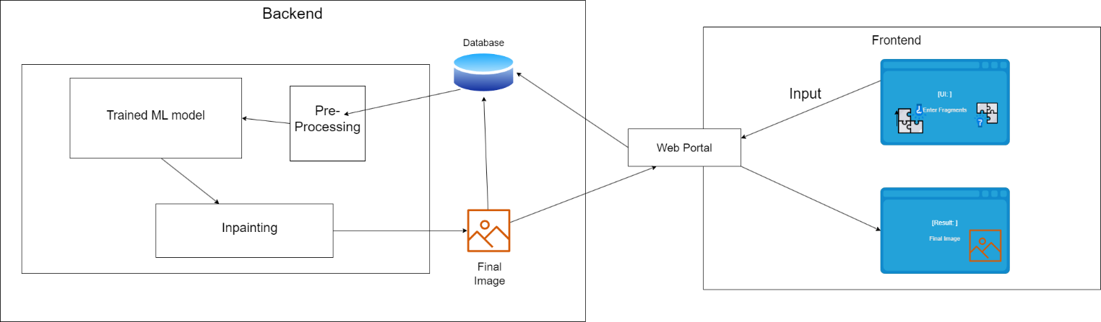

*Figure 7: High Level Design View*

**5.5 Design Description**

**Logical User Groups:**

**End Users**: Users who interact with the web application to upload broken images, view the reassembled and inpainted images, and download the results.

**Application Components:**

**Web Front-End:** A user interface that allows the end users to interact with the system by uploading images, viewing results, and downloading the outputs.

**Image Preprocessing Module:** A component that preprocesses the input images by extracting the broken image pieces and resizing them to a suitable size for the CNN model.

**ML Model:** A deep learning model that reassembles the broken image pieces into a complete image.

**Inpainting Module:** A component that uses a GAN and a diffusion model to fill in any missing parts of the reassembled image.

**Image Postprocessing Module:** A component that post-processes the final image by resizing it to the original size and converting it to a suitable format for display and download.

**Data Components:**

**Image Dataset:** A dataset of broken images used for training and validation of the ML models.

**Trained ML models:** Pretrained models used for reassembling and inpainting broken images.

**User Uploaded Images:** Broken images uploaded by the end users for processing.

**Interfacing Systems:**

**Deep Learning Framework:** A software framework used to train and deploy the ML models.

**Web Server:** A server that hosts the web application and provides access to the deep learning models and the image processing modules.

**5.5.1 Master Class Diagram**

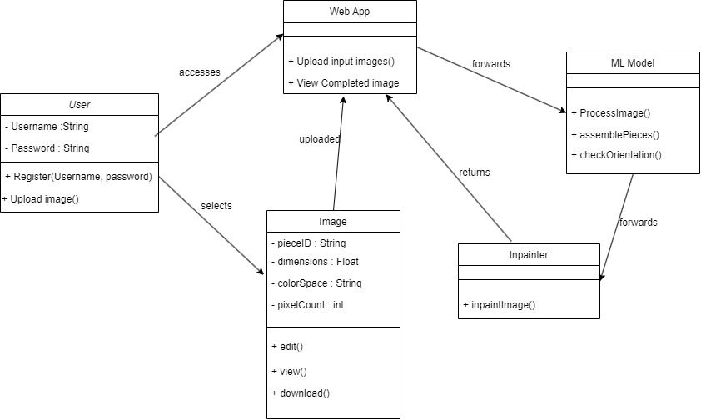

*Figure 8: Master-Class diagram*

**5.5.2 Reusability Considerations**

The Reusability considerations are:

**Use of libraries and frameworks:** The system makes use of pre-built libraries and frameworks for the Frontend which saves time and can be easily replaced.

**Modular design:** The system is designed using a modular approach, where each module serves a specific functionality and can be reused in different projects. One example is the inpainting module which fills in missing gaps in an image using the features of its neighbouring pieces.

**Standardization of interfaces:** The email bot can follow a standard interface for its components, making it easier to swap out components and reuse them in other projects.

**Documentation:** The system’s documentation contains a detailed explanation of all reusable components, making it easier for developers to understand how to use them in their projects. Included in this documentation should be use cases, examples, and any other pertinent details.

**CHAPTER 6**

**PROPOSED METHODOLOGY**

To reassemble a fragmented image, we streamline the process by pre-processing all pieces to fit a 2x2 jigsaw puzzle configuration, simplifying the reconstruction task. In cases where pieces have non-linear shapes, padding is applied to make each piece square. This transformation not only facilitates a more manageable solution but also transforms the challenge into assembling a jigsaw puzzle with four uniform pieces, effectively reducing the overall complexity of the task. Now, we extract the features from each piece and using a CNN trained on similar images, we then arrange the pieces correctly. Then, if there are any missing pieces or gaps to be filled in the resultant image, it is fed to the inpainting module where the model detects if any feature is missing and inpaints it. The whole outline of the system is given below

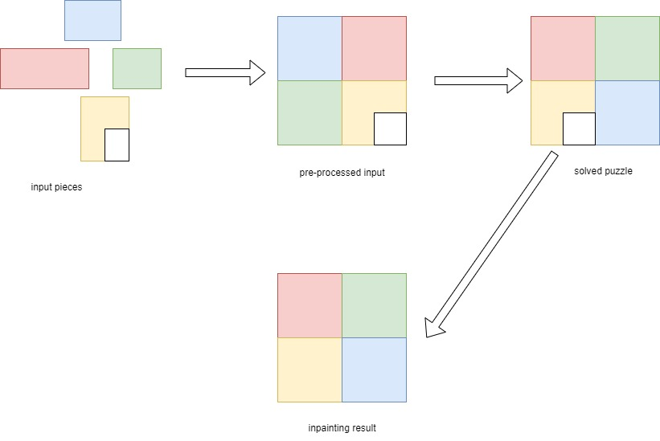

*Figure 9: System Outline*

The whole process can be explained in three modules:-

**User Input and Pre-processing**: A user uploads 4 images of a single image which have been broken/fragmented- these now act as 4 pieces to a jigsaw puzzle. Pre-processing includes resizing all the 4 images into squares and removing any noise. To facilitate even the smallest of pictures, we have taken piece size of 50x50 pixels. After resizing the pieces, they are given index values from 0 to 3 and are stitched together by Python’s robust image manipulation modules . This new image of 4 pieces, sized 200x200 pixels acts as the input image to our puzzle solving model.

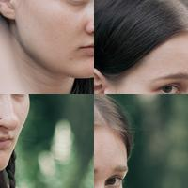 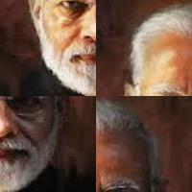 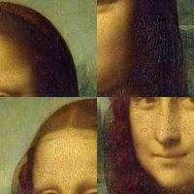

*Figure 10 : Input to the Jigsaw-Solver*

**Jigsaw Solver:** The Jigsaw Solver module plays a crucial role in solving the shuffled puzzle input image. It utilizes a Convolutional Neural Network (CNN) to analyse and recognize features within each of the four puzzle pieces. These identified features are then compressed into a single vector – one for each piece. This compressed vector is then passed through another neural network, a specially designed CNN, which generates an output vector containing the anticipated positions of the individual puzzle pieces. Subsequently, the original input pieces are rearranged based on these predicted positions, ultimately culminating in the formation of the complete and solved image.

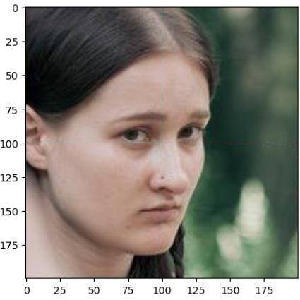 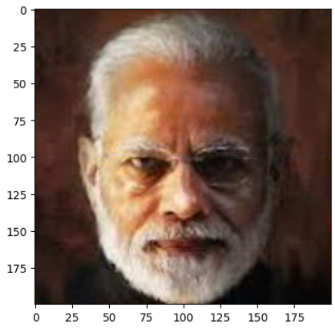 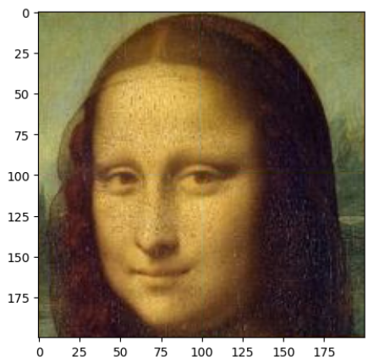

*Figure 11: Outputs generated by the Jigsaw-Solver*

**Inpainting Module:** Following the solution of the jigsaw puzzle, if there are any missing gaps (indicated by white/black areas in the output image), the inpainting module is engaged. This module introduces noise to the input image, generating a mask. A U-Net architecture, a variant of an encoder-decoder, is applied to denoise the image. This process is conditioned on both the original image and the mask. The inpainting module runs for multiple layers, progressively reducing noise and comparing the similarity of the generated pixels with the training dataset.

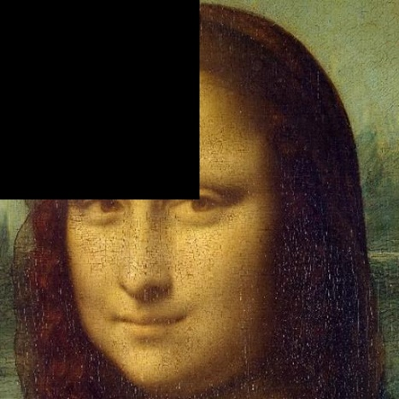 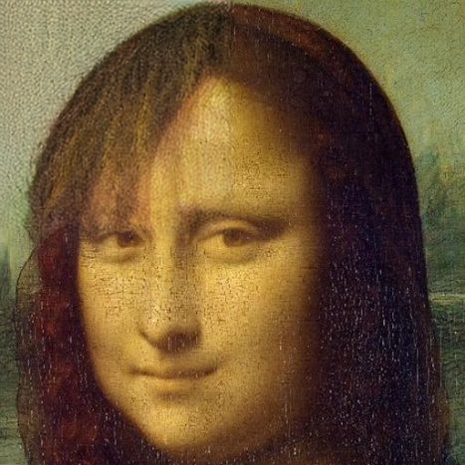

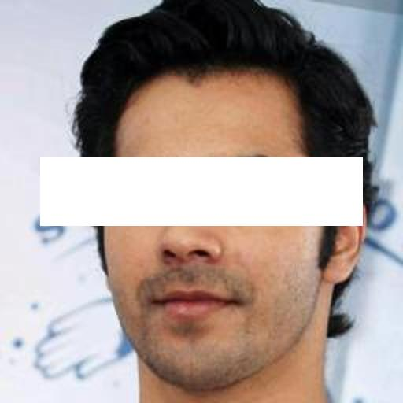 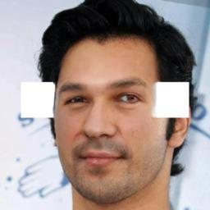

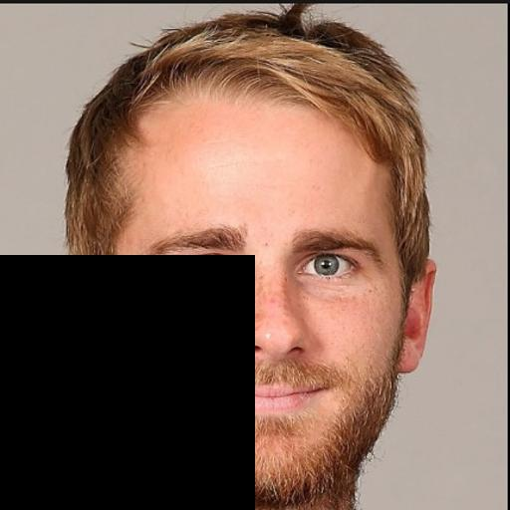 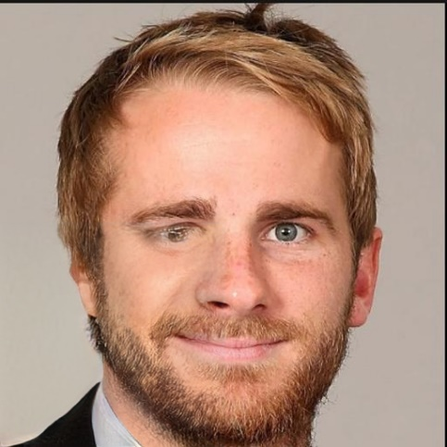

*Figure 12: Inpainting results(right) on the given inputs(left)*

**CHAPTER 7**

**IMPLEMENTATION AND PSEUDOCODE**

The dataset we’ve used is the IRDBT dataset for Cheque restoration and the CelebA dataset for pictures of human faces which forms our base for photo restoration. To create our dataset of 4 pieces from an image, we do it in 2 steps:- Resize the image to a square and then break it into 4 pieces, randomly rearrange them and save their original positions in a csv file(only for training data)

**7.1 Pseudocode for Resizing and creating the jigsaw puzzle**

This code cuts an image obtained from the path into 4 pieces, randomly shuffles them, and saves the original position of the 4 pieces in an array.

**Code Snippet:**

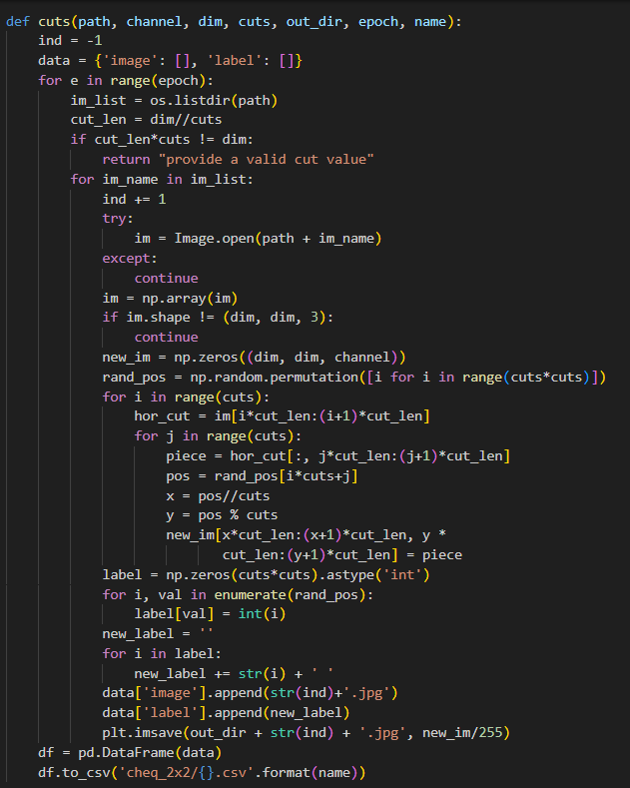

**Algorithm:**

1. Initialize ind to -1 and create an empty dictionary data with keys 'image' and 'label'.

2. For each epoch (e in range(epoch)):

a. Get a list of image file names in the specified directory.

For each image file name (image_name) in the list:

i. Increment ind by 1.

ii. Try opening the image at path + image_name.

iii. If successful, convert the image to an array.

iv. Check if the image is a square with dimensions dim. If not, skip to the next image.

v. Create a new empty image new_image.

vi. Shuffle positions to determine the order of pieces (shuffled_positions).

For each row in the puzzle (i in range(cuts)):

For each column in the row (j in range(cuts)):

vii. Extract a piece from the original image (piece).

viii. Determine the position of the piece in the shuffled order (position).

ix. Place the piece in the new image at the determined position.

x. Create labels based on the shuffled positions.

xi. Add data (file name and label) to the dictionary.

xii. Save the new image as a file in the specified output directory.

3. Create a DataFrame from the data dictionary.

4. Save the DataFrame as a CSV file with the specified name (name).

**7.2 Pseudocode for Jigsaw-Solving Model**

The model first uses a CNN which takes a tensor containing number of pieces, dimensions and colour gradients which is (4,100,100,3) in our case. Then we apply a Time-Distributed layer over it which will apply the CNN layer over all 4 pieces and then normalizes it. This is done several times with minimal pooling to retain edge info. Then the applied layers are flattened which combines all the features and is then reshaped to our original image size and then sent as the output. The feature extraction uses a relu layer whereas the reshaping uses softmax as activation layers

**Code Snippet:-**

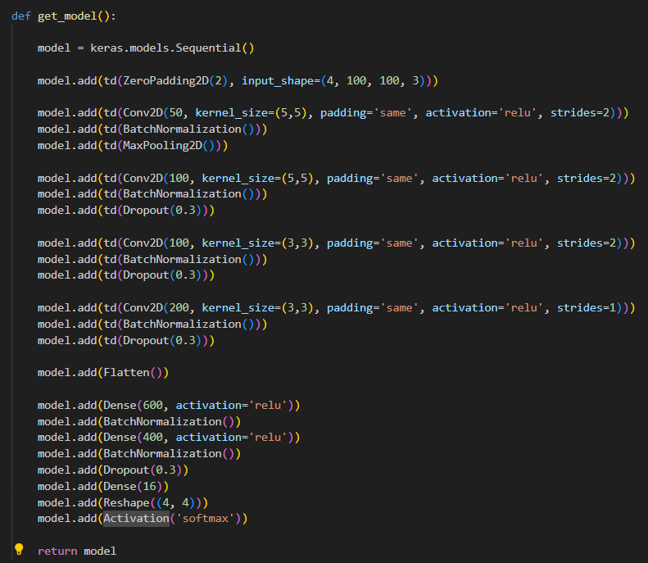

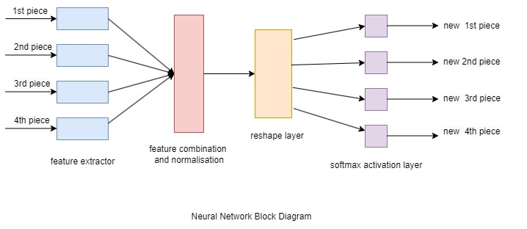

*Figure 13: Jigsaw Model Block Diagram*

**7.3 Inpainting**

**Code Snippet:-**

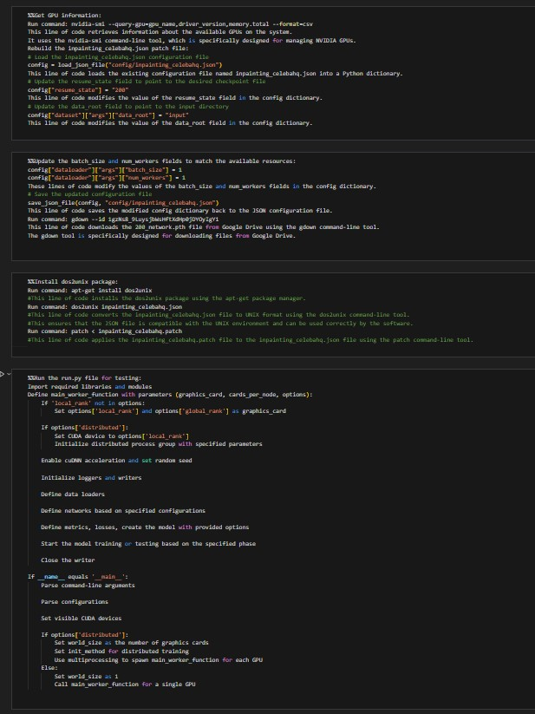

**Psuedocode Explained**

1>Obtain GPU details: It queries and retrieves details about the NVIDIA GPUs that are accessible on the system using the nvidia-smi command.

2>Rebuild the patch file inpainting_celebahq.json: loads an existing configuration file called inpainting_celebahq.json into a Python dictionary, adjusts values for batch_size and num_workers, edits the columns resume_state and data_root in that dictionary, then saves the revised configuration back to the original JSON file.

3>Get a Model file : uses Google Drive to download the 200_network.pth file using the gdown command-line function.

4>Install the dos2unix package: To assure compatibility with the UNIX environment, install the dos2unix package using the apt-get package management and convert the inpainting_celebahq.json file to UNIX format.

5>Put on a patch: uses the patch command-line tool to apply the inpainting_celebahq.patch file to the inpainting_celebahq.json file.

6> Open the test.py file and execute it. The functions and logic in this area of code are used to control how a Python script (run.py) is executed. This includes importing the necessary modules and libraries.Creating a primary worker function that will handle things like configuring GPU settings, beginning distributed training processes, specifying data loaders, networks, metrics, losses, and models, and initiating training or testing depending on predefined conditions,managing a range of situations, including single GPU execution and distributed training over several GPUs.

**CHAPTER 8**

**RESULTS AND DISCUSSION**

As per our initial estimates, we wanted to rearrange irregular pieces which became overcomplicated because 1)Determining the correct orientation proved to be a difficult with the possibility of infinite orientations to be solved for pieces more than 3 pieces 2)presence of a lot of factors which included color, shape, orientation of the pieces and then edge angles, length and orientation for each edge of all the pieces which required a combination of many ML models which was too difficult and 3) no clear knowledge of an outer frame within which to fit the pieces.We then treated each irregularly shaped piece as a square and applied padding, when necessary, effectively standardizing the pieces. This simplification aimed to streamline the puzzle-solving process by reducing the number of orientations to consider.

**8.1 Document Restoration**

To try if we can solve an irregular shaped image, we took 4 orientations of cheques including two diagonal alignments and then broke them into 4 pieces to see if the model can recognise similar patterns

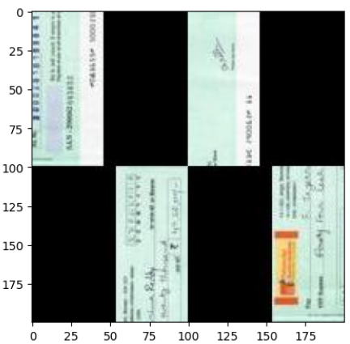 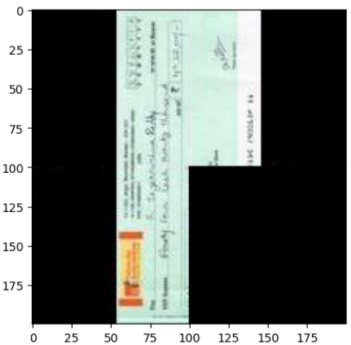

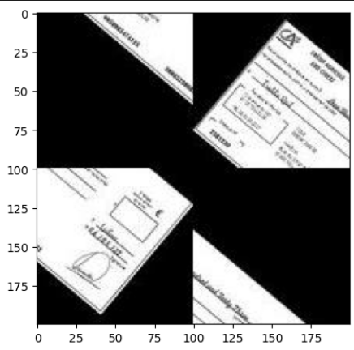 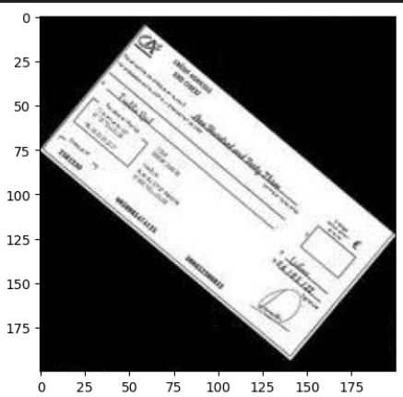

*Figure 14: Solving irregular pieced cheques*

But solving this puzzle was a bit easy for the model and we obtained a 95% accuracy because:

**1. Standardization of Cheques:** Cheques typically adhere to a standardized format and layout. They often contain fixed sections such as the payer's information, payee's information, amount, and other essential details. This consistency in structure means that the visual content of different cheques shares common patterns and features.

**2. Repetitive Elements**: Many cheques are issued by the same financial institution, and organizations often use pre-printed cheque forms with standardized designs. As a result, common elements such as logos, fonts, background patterns, and overall layout are frequently repeated across cheques.

**3. Limited Variability:** The variation in the visual appearance of cheques within a specific context (such as those issued by a particular bank) might be limited and we were limited by our dataset which only had a few famous banks

**4. Consistent Image Characteristics:** When a cheque is divided into pieces for a jigsaw puzzle, the individual pieces may still contain recognizable elements like logos, signatures, or specific patterns. The consistent presence of these recognizable features makes it easier for a machine learning model to learn and predict the correct arrangement.

**8.2 Restoring Human Photos or Portrait Paintings**

In the case of Human Photos, the model was only trained on the Celeb-HQ dataset consisting of around 25000 images of celebrities. For testing , we took a collection of a few paintings, a few animated/cartoon photos and some human photos which weren’t in the Celeb-HQ dataset.  
Results obtained are:-

**8.2.1 Human Faces:** We tested the model on human faces ranging from kids to old-aged people

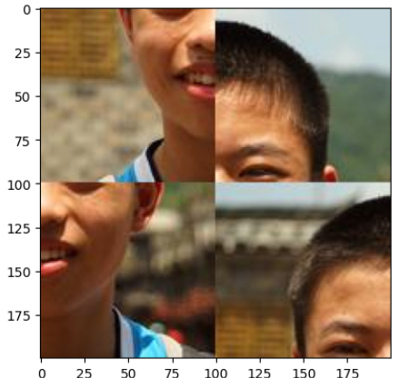 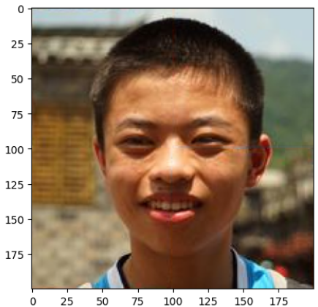

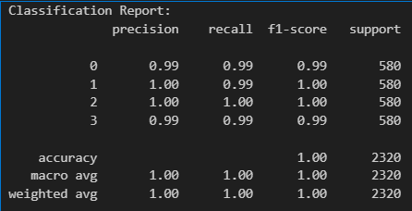 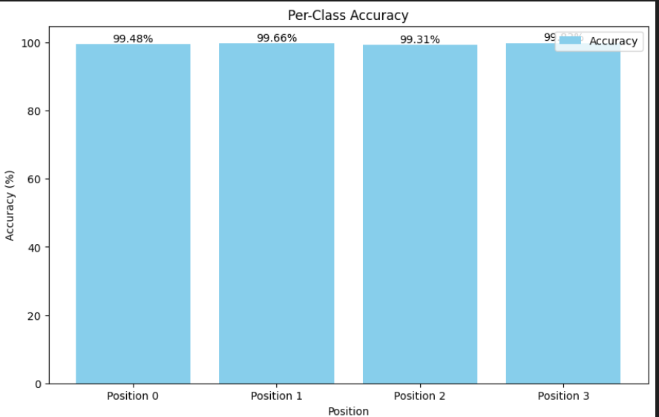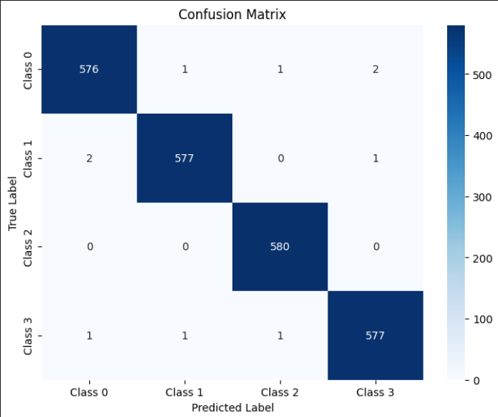

*Figure 15: Results and Statistics for human faces*

Accuracy of prediction for each position is pretty well above 98% . Since Human faces are similar to the dataset, we’ve trained it on, we find a good accuracy

**8.2.2 Paintings**

Even though the scope of portrait paintings is very huge and each one being subjective with thousands of art styles, we tried our model and wanted to see if it would be able to restore a fragmented painting containing a human face but in a different style. In styles, I’ve also included animated photographs since technically they’re also paintings.

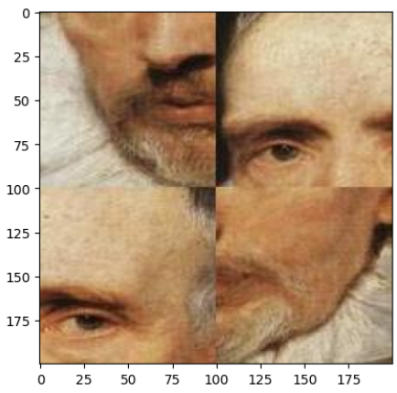 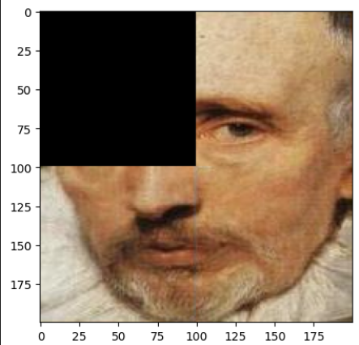

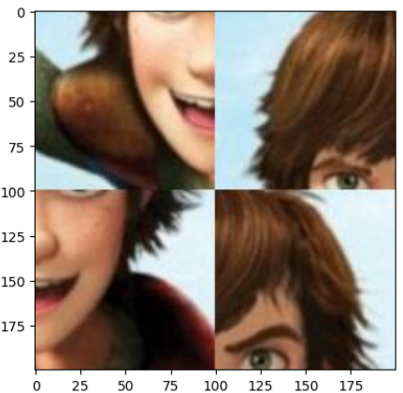 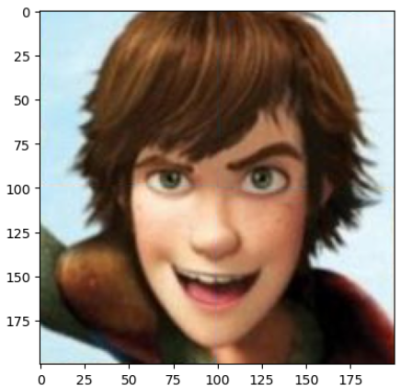

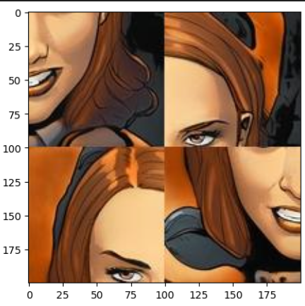 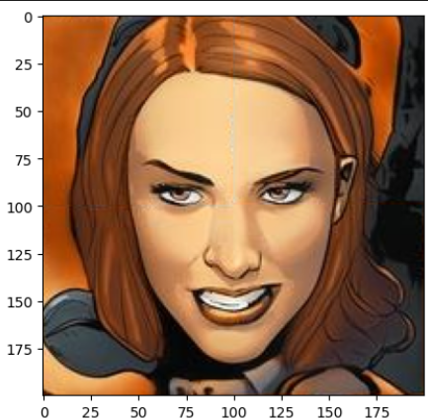

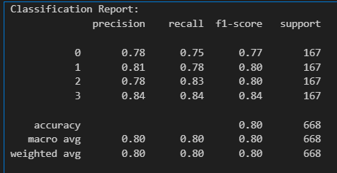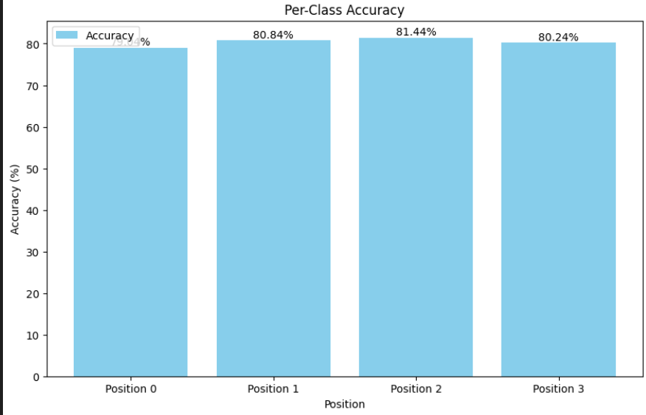

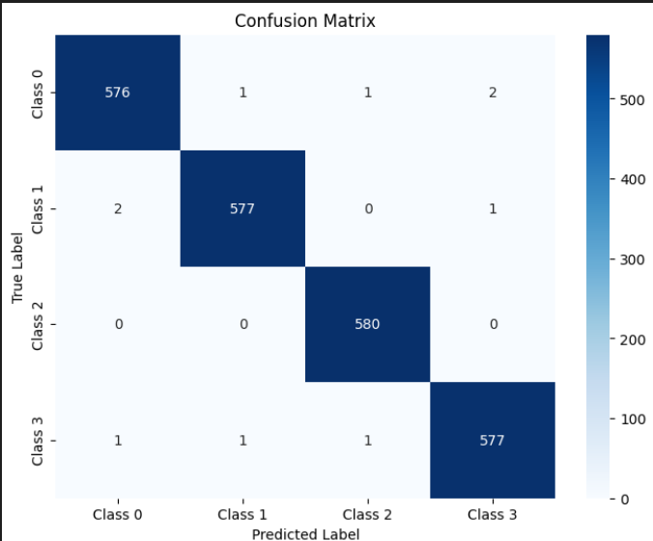

*Figure 16: Results and Statistics for Paintings*

On further analysis, we found that paintings from medieval era like 20th century and 19th-century paintings’ pieces are often misread by the model because of the art style . This limitation underscores the importance of considering historical and cultural context when developing and evaluating models for reassembling old paintings. Because of the inclusion of such paintings in our testing data, we saw an accuracy drop from 94% to 80%.

**8.3 Comparative display for inpainting results**

Using the inpainting methods from [2] and [4] , we did a comparative study of inpainting results for both models . While the diffusion model doesn’t require any masks, the GAN model needs a mask image to determine exactly where to inpaint the image.

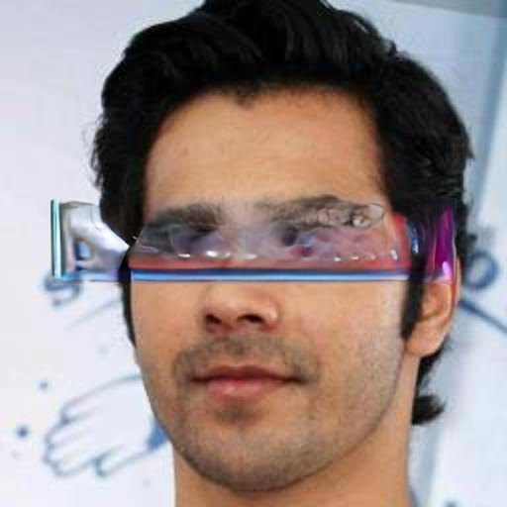

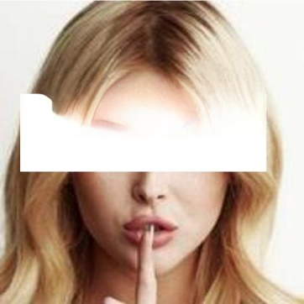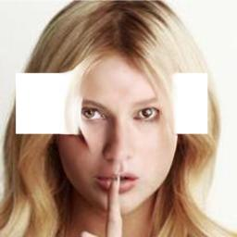

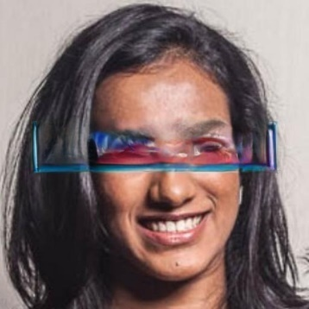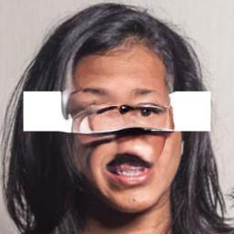

*Figure 17: GAN (left) vs Diffusion model(right) inpainting*

Although the results may look bad without a mask, we can clearly see that the GAN model inpaints other features of a face other the eye pretty well whereas the Diffusion model generates the eyes pretty well.

But when a mask is given to the GAN model, it gives pretty satisfactory results:

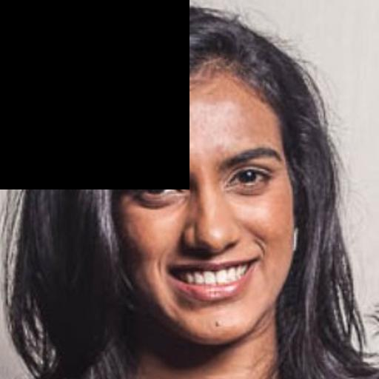  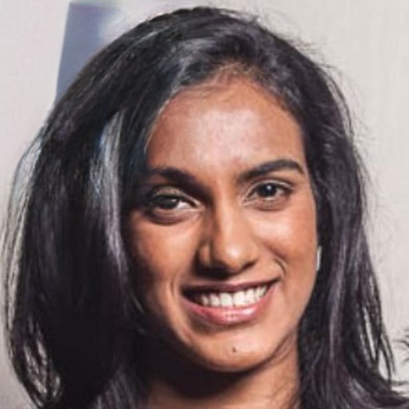

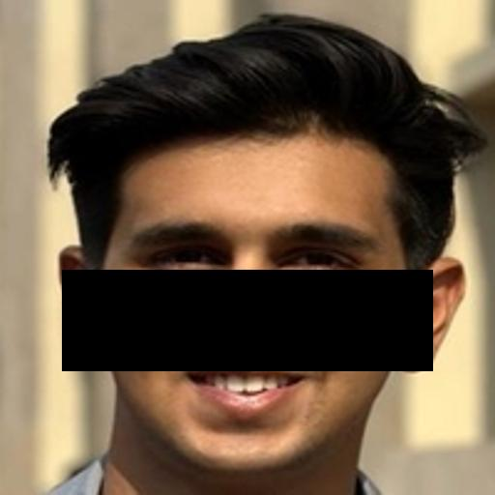  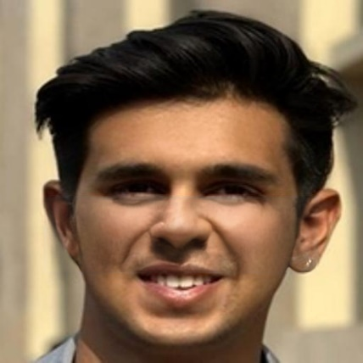

*Figure 18: GAN model inpainting (From left to right: input image, mask, and output image)*

**CHAPTER 9**

**CONCLUSION AND FUTURE WORK**

In summary, the investigation into reconstructing fragmented images through a jigsaw puzzle methodology has offered valuable insights into the challenges and potential resolutions within the realm of image reconstruction. This study has successfully showcased the viability of utilizing computational approaches to piece together images from their disassembled components, closely emulating the traditional process of solving a jigsaw puzzle. While our methodology focused on square images, reassembling irregularly shaped pieces poses a formidable challenge, particularly due to the tedious and inefficient process of analysing each piece's features. There is a pressing need for the development and implementation of more advanced models to tackle these intricacies effectively.

Furthermore, inpainting, as a technique, holds significant promise in various contemporary applications. However, the exploration of context-free inpainting remains an area ripe for further investigation. If successfully implemented, such a model could find applications ranging from artifact restoration and medical imaging to image forensics, significantly expanding the potential use cases for inpainting technology in diverse fields. The exploration of more sophisticated and context-aware inpainting models stands as a crucial next step in advancing the capabilities of these technologies and unlocking their full potential across a spectrum of real-world scenarios.

**REFERENCE / BIBLIOGRAPHY**

[1] M. Noroozi and P. Favaro, “Unsupervised learning of visual representations by solving jigsaw puzzles,” in Computer Vision – ECCV 2016, B. Leibe, J. Matas, N. Sebe and M. Welling, Eds. Cham: Springer International Publishing, 2016, pp. 69-84.

DOI: 10.48550/arXiv.1603.09246

[2] C. Saharia, W. Chan, H. Chang, C. A. Lee, J. Ho, T. Salimans, D. J. Fleet and M. Norouzi, “Palette: Image-to-Image Diffusion Models,” arXiv:2111.05826 [cs.CV], Nov. 2021.

DOI : 10.48550/arXiv.2111.05826

[3] D. Sholomon, O. David and N. S. Netanyahu, “A Genetic Algorithm-Based Solver for Very Large Jigsaw Puzzles,” in 2013 IEEE Conference on Computer Vision and Pattern Recognition, Portland, OR, USA, 2013, pp. 1767-1774.

DOI: 10.1109/CVPR.2013.231

[4] W. Li, Z. Lin, K. Zhou, L. Qi, Y. Wang and J. Jia, “MAT: Mask-Aware Transformer for Large Hole Image Inpainting,” in Proceedings of the IEEE/CVF Conference on Computer Vision and Pattern Recognition, 2022, pp. 10758-10768

DOI: 10.48550/arXiv.2203.15270

[5] M. Tewari, S. Jana and R. Parekh, "An Automated System for Image Reconstruction from Distorted Image Fragments," 2017 International Conference on Computer, Electrical & Communication Engineering (ICCECE), Kolkata, India, 2017, pp.1-6

DOI:10.1109/ICCECE.2017.8526211

**APPENDIX A: DEFINITIONS, ACRONYMS AND ABBREVIATIONS**

**API:** Application Programming Interface.

**Database:** A structured collection of data that is stored and managed in a computer system.

**GUI:** Graphical User Interface.

**RGB:** Red-Green-Blue

**MERN:** MongoDB, ExpressJS, ReactJS and NodeJS – they form the complete package to develop a web application.

**ML:** Machine Learning

**CNN:** Convolutional Neural Network is a class of artificial neural network most commonly applied to analyse visual imagery.

**GAN:** Generative Adversarial Network is a class of machine learning frameworks and a prominent framework for approaching generative AI.

**SURF:** Speeded Up Robust Features is a fast and robust algorithm for local, similarity invariant representation and comparison of images

**SIFT:** Scale-Invariant Feature Transform is an algorithm in computer vision to detect and describe local features in images

**Accuracy:** The extent to which the system's output matches the expected or desired output.